共同設定都是夏月、平日、晴天

S1測試2段式 無累計電價 無停電 無設備啟用
📥 收到的 config： {'pricing': 'two_stage', 'season': 'summer', 'day_type': 'weekday', 'weather': 'sunny', 'monthly_cumulative_kwh': 0, 'outage': None, 'device_schedules': []}
🔁 [重試檢查] 第 0 次嘗試，目前 bess_override=None
🔎 [天氣檢查] PSO 這次使用的 PV 檔案：C:\projects\hems-simulation-web\data\01_raw\pv_curve_15min.csv
🔎 [PSO輸入比對] 13:00~15:00 PV: [4.78867, 4.6735299999999995, 4.56147, 4.415, 4.25413, 4.07467, 3.8710700000000005, 3.6598]
🔎 [PSO輸入比對] 13:00~15:00 critical_load_kw: [0.10398015000000001, 0.104320565, 0.105352634, 0.10483838199999998, 0.105803373, 0.10691419400000002, 0.10865781599999999, 0.11004641800000001]
🎯 [PSO自評] PSO演算法自己算出來的理論總成本(電費+懲罰項): -162.48927667849046
🔎 [天氣檢查] 離線驗證這次使用的 PV 檔案：pv_curve_15min.csv
🔍 [除錯] 目前實際使用的電池指令是: New Storage.Battery_Sys phases=1 bus1=Inv_AC.1.2 kV=0.22 kVA=6.0 kWrated=5.0 kWhrated=20.0 pf=1.0 %stored=40 %reserve=0 %IdlingKw=0 %EffCharge=95 %EffDischarge=95 DispMode=External
基準電路建置完成！開始進行 15 分鐘步進模擬 (模式: PSO)..

F12 Response
- {status: "success", message: "切換成功", pso_total_cost: 24.71, baseline_total_cost: 2.65,…}
baseline_adjusted_cost: -101.17
baseline_battery_asset_value: 0
baseline_export_kwh: 18.447
baseline_export_revenue: 103.82
baseline_had_overload: false
baseline_total_cost: 2.65
message: "切換成功"
pso_adjusted_cost: -161.77
pso_battery_asset_value: 0
pso_export_kwh: 33.135
pso_export_revenue: 186.48
pso_total_cost: 24.71
savings: 60.6
status: "success"

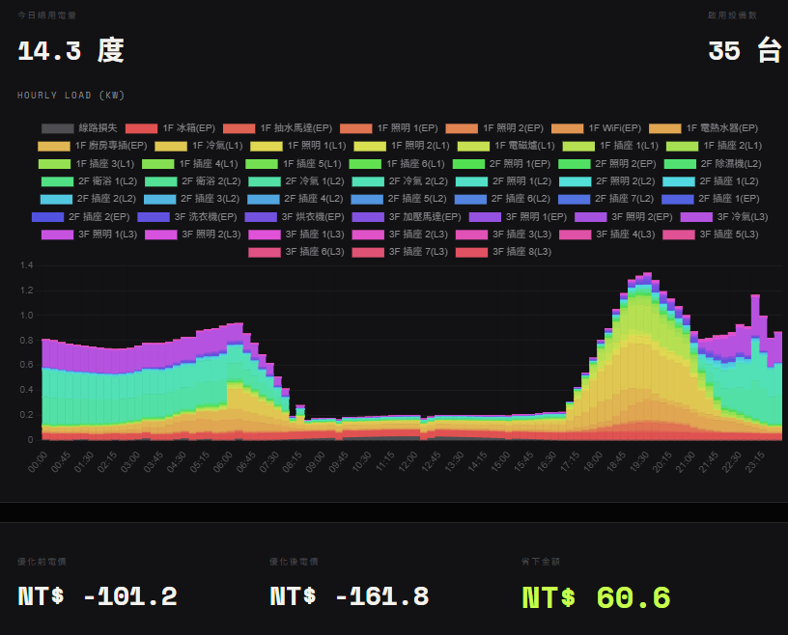
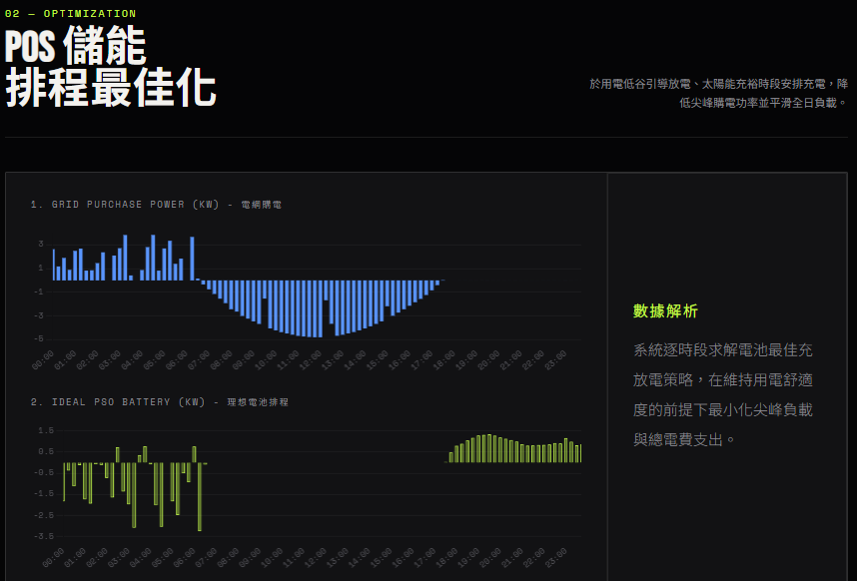

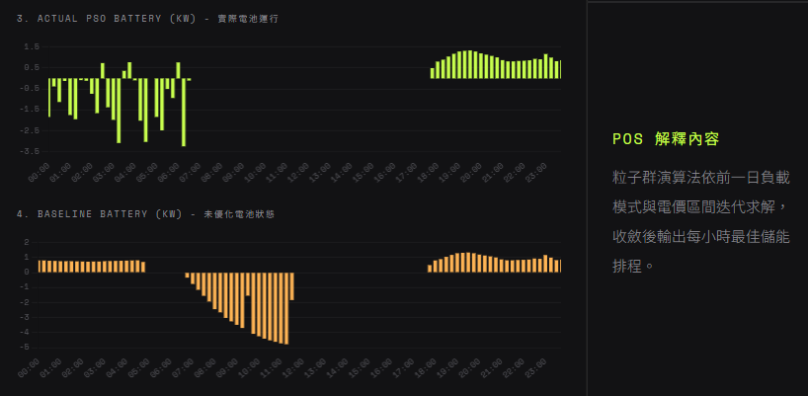
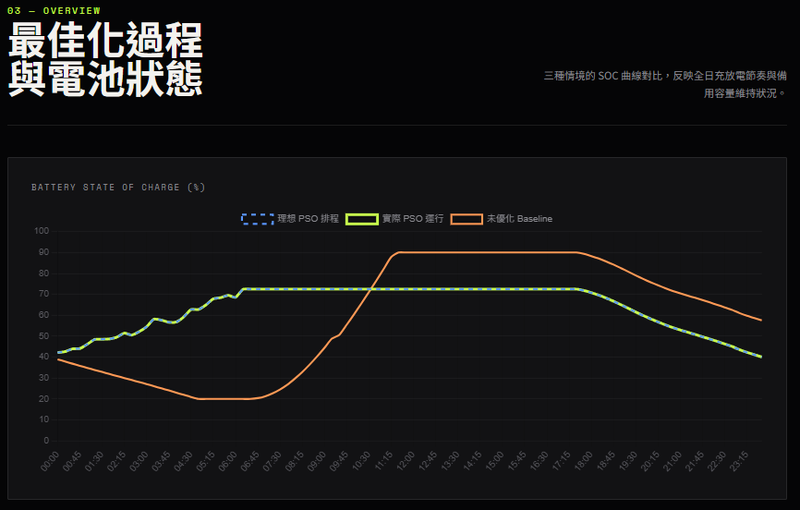

pso起始與結束電量
Time | soc
00:00 | 42.17
23:45 | 40.05

Baseline的起始與結束電量
Time | soc
00:00 | 38.95
23:45 | 57.55

S2測試3段式 無累計電價 無停電 無設備啟用
📥 收到的 config： {'pricing': 'three_stage', 'season': 'summer', 'day_type': 'weekday', 'weather': 'sunny', 'monthly_cumulative_kwh': 0, 'outage': None, 'device_schedules': []}
🔁 [重試檢查] 第 0 次嘗試，目前 bess_override=None
🔎 [天氣檢查] PSO 這次使用的 PV 檔案：C:\projects\hems-simulation-web\data\01_raw\pv_curve_15min.csv
🔎 [PSO輸入比對] 13:00~15:00 PV: [4.78867, 4.6735299999999995, 4.56147, 4.415, 4.25413, 4.07467, 3.8710700000000005, 3.6598]
🔎 [PSO輸入比對] 13:00~15:00 critical_load_kw: [0.10398015000000001, 0.104320565, 0.105352634, 0.10483838199999998, 0.105803373, 0.10691419400000002, 0.10865781599999999, 0.11004641800000001]
🎯 [PSO自評] PSO演算法自己算出來的理論總成本(電費+懲罰項): -155.0460113844004
🔎 [天氣檢查] 離線驗證這次使用的 PV 檔案：pv_curve_15min.csv
🔍 [除錯] 目前實際使用的電池指令是: New Storage.Battery_Sys phases=1 bus1=Inv_AC.1.2 kV=0.22 kVA=6.0 kWrated=5.0 kWhrated=20.0 pf=1.0 %stored=40 %reserve=0 %IdlingKw=0 %EffCharge=95 %EffDischarge=95 DispMode=External
基準電路建置完成！開始進行 15 分鐘步進模擬 (模式: PSO)...
F12 Response
- {status: "success", message: "切換成功", pso_total_cost: 32.2, baseline_total_cost: 2.67,…}
baseline_adjusted_cost: -101.15
baseline_battery_asset_value: 0
baseline_export_kwh: 18.447
baseline_export_revenue: 103.82
baseline_had_overload: false
baseline_total_cost: 2.67
message: "切換成功"
pso_adjusted_cost: -154.28
pso_battery_asset_value: 0
pso_export_kwh: 33.135
pso_export_revenue: 186.48
pso_total_cost: 32.2
savings: 53.13
status: "success"

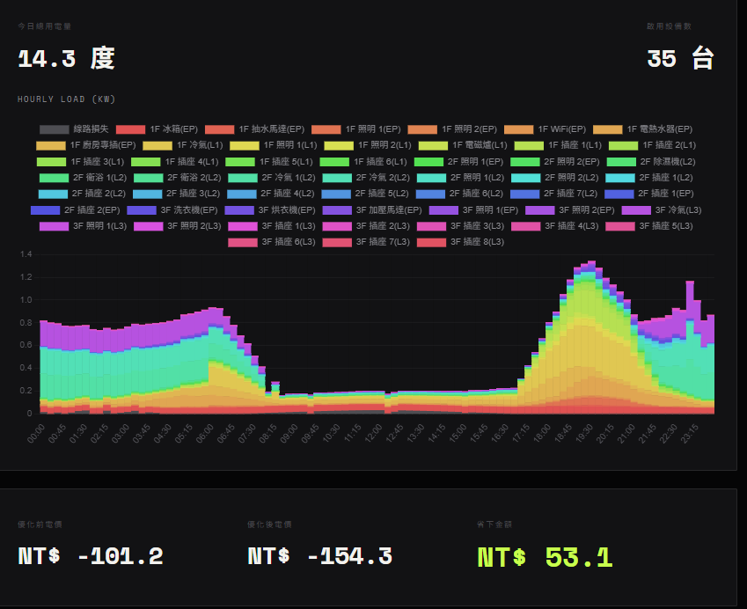
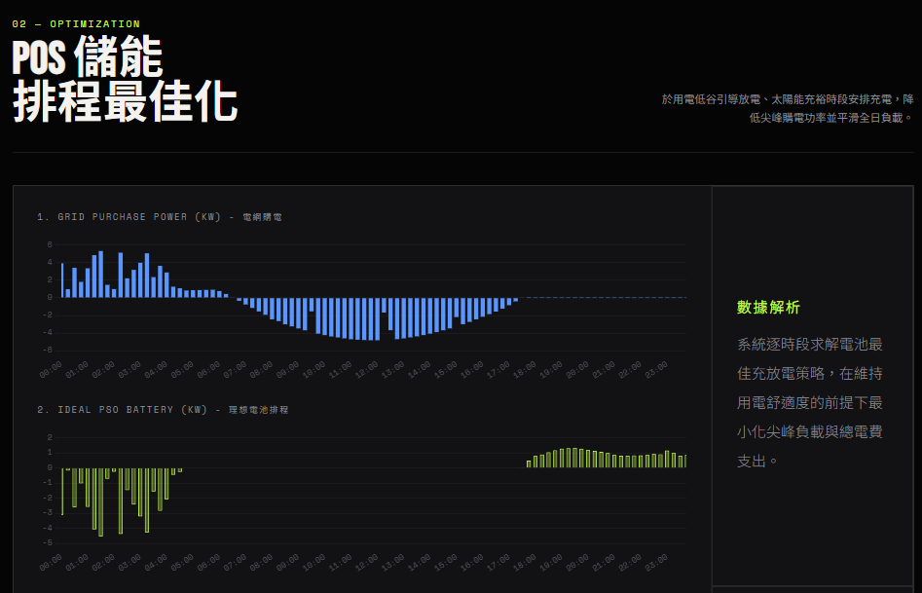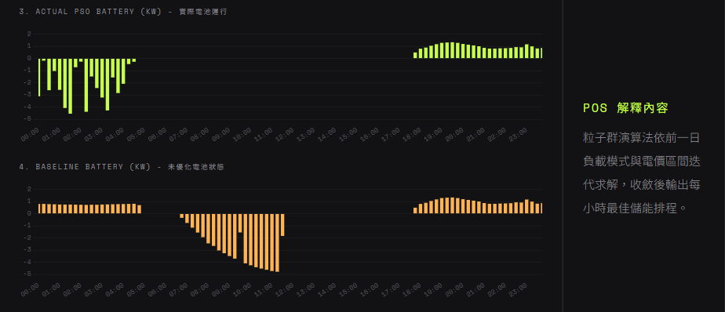
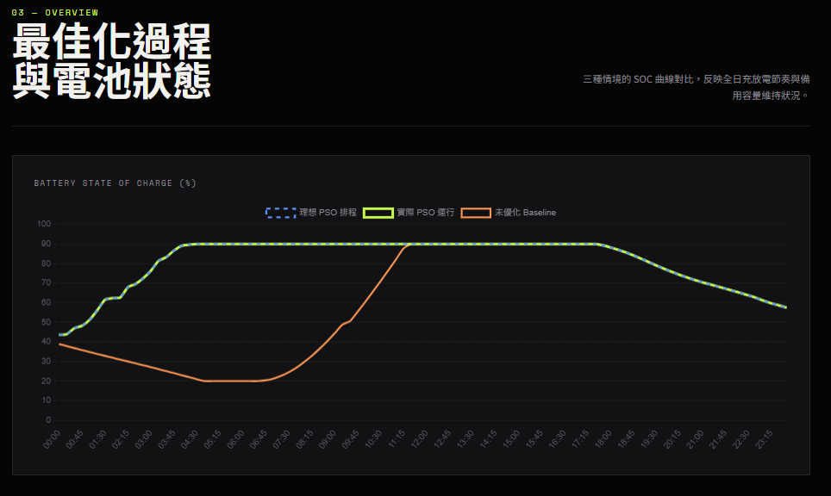
pso起始與結束電量
Time | soc
00:00 | 43.69
23:45 | 57.55

Baseline的起始與結束電量
Time | soc
00:00 | 38.95
23:45 | 57.55

S3測試 累計電價 已累計0 無停電 無設備啟用
📥 收到的 config： {'pricing': 'progressive', 'season': 'summer', 'day_type': 'weekday', 'weather': 'sunny', 'monthly_cumulative_kwh': 0, 'outage': None, 'device_schedules': []}
🔁 [重試檢查] 第 0 次嘗試，目前 bess_override=None
🔎 [天氣檢查] PSO 這次使用的 PV 檔案：C:\projects\hems-simulation-web\data\01_raw\pv_curve_15min.csv
🔎 [PSO輸入比對] 13:00~15:00 PV: [4.78867, 4.6735299999999995, 4.56147, 4.415, 4.25413, 4.07467, 3.8710700000000005, 3.6598]
🔎 [PSO輸入比對] 13:00~15:00 critical_load_kw: [0.10398015000000001, 0.104320565, 0.105352634, 0.10483838199999998, 0.105803373, 0.10691419400000002, 0.10865781599999999, 0.11004641800000001]
🎯 [PSO自評] PSO演算法自己算出來的理論總成本(電費+懲罰項): -167.14736597677623
🔎 [天氣檢查] 離線驗證這次使用的 PV 檔案：pv_curve_15min.csv
🔍 [除錯] 目前實際使用的電池指令是: New Storage.Battery_Sys phases=1 bus1=Inv_AC.1.2 kV=0.22 kVA=6.0 kWrated=5.0 kWhrated=20.0 pf=1.0 %stored=40 %reserve=0 %IdlingKw=0 %EffCharge=95 %EffDischarge=95 DispMode=External
基準電路建置完成！開始進行 15 分鐘步進模擬 (模式: PSO)...

F12 Response
- {status: "success", message: "切換成功", pso_total_cost: 19.96, baseline_total_cost: 2.24,…}
baseline_adjusted_cost: -101.58
baseline_battery_asset_value: 0
baseline_export_kwh: 18.447
baseline_export_revenue: 103.82
baseline_had_overload: false
baseline_total_cost: 2.24
message: "切換成功"
pso_adjusted_cost: -166.52
pso_battery_asset_value: 0
pso_export_kwh: 33.135
pso_export_revenue: 186.48
pso_total_cost: 19.96
savings: 64.94
status: "success"
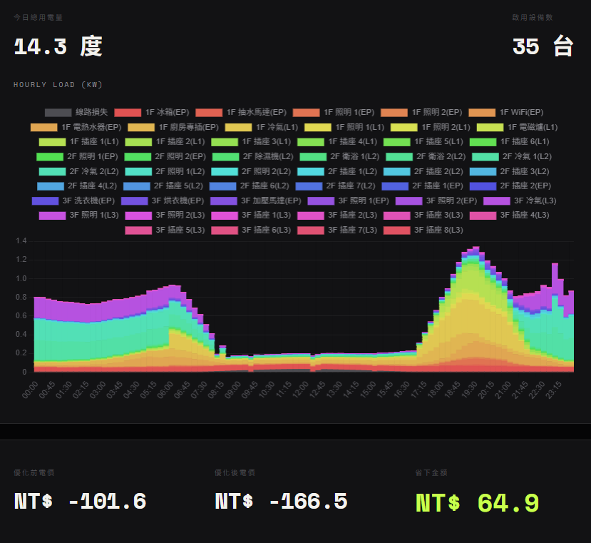
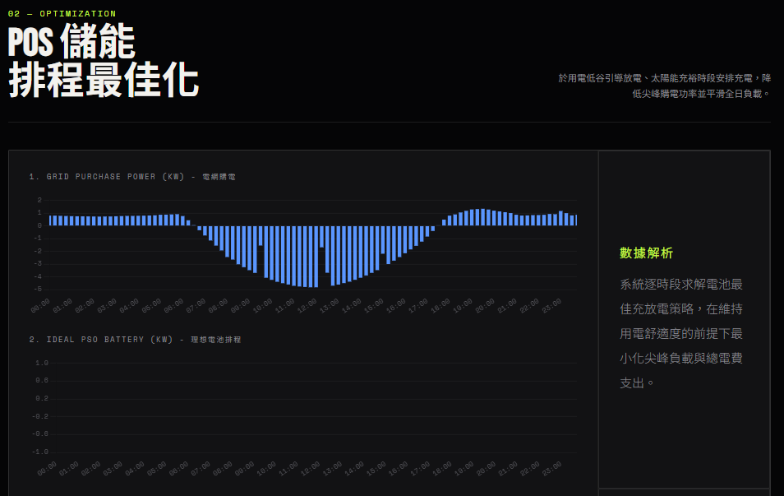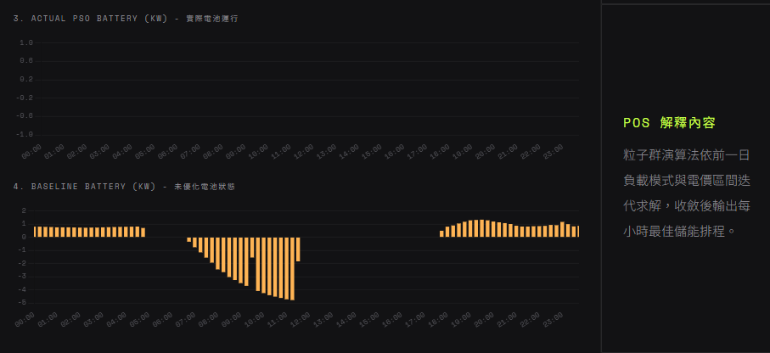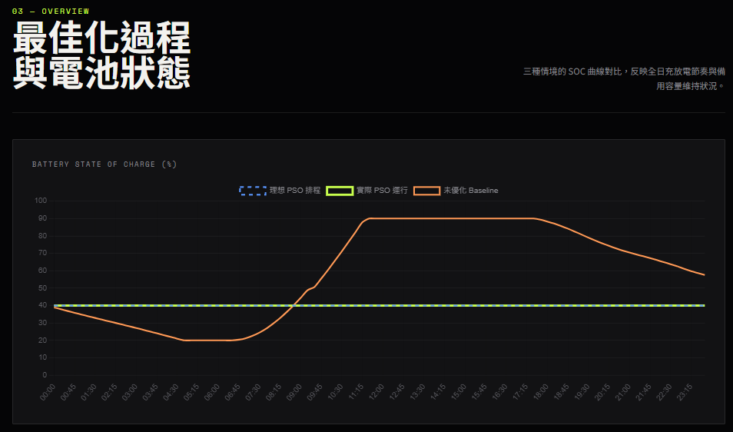
pso起始與結束電量
Time | soc
00:00 | 40
23:45 | 40

Baseline的起始與結束電量
Time | soc
00:00 | 38.95
23:45 | 57.55

S4測試 累計電價 已累計800 無設備啟用
📥 收到的 config： {'pricing': 'progressive', 'season': 'summer', 'day_type': 'weekday', 'weather': 'sunny', 'monthly_cumulative_kwh': 800, 'outage': None, 'device_schedules': []}
🔁 [重試檢查] 第 0 次嘗試，目前 bess_override=None
🔎 [天氣檢查] PSO 這次使用的 PV 檔案：C:\projects\hems-simulation-web\data\01_raw\pv_curve_15min.csv
🔎 [PSO輸入比對] 13:00~15:00 PV: [4.78867, 4.6735299999999995, 4.56147, 4.415, 4.25413, 4.07467, 3.8710700000000005, 3.6598]
🔎 [PSO輸入比對] 13:00~15:00 critical_load_kw: [0.10398015000000001, 0.104320565, 0.105352634, 0.10483838199999998, 0.105803373, 0.10691419400000002, 0.10865781599999999, 0.11004641800000001]
🎯 [PSO自評] PSO演算法自己算出來的理論總成本(電費+懲罰項): -116.80305371592335
🔎 [天氣檢查] 離線驗證這次使用的 PV 檔案：pv_curve_15min.csv
🔍 [除錯] 目前實際使用的電池指令是: New Storage.Battery_Sys phases=1 bus1=Inv_AC.1.2 kV=0.22 kVA=6.0 kWrated=5.0 kWhrated=20.0 pf=1.0 %stored=40 %reserve=0 %IdlingKw=0 %EffCharge=95 %EffDischarge=95 DispMode=External
基準電路建置完成！開始進行 15 分鐘步進模擬 (模式: PSO)...

F12 Response
- {status: "success", message: "切換成功", pso_total_cost: 12.61, baseline_total_cost: 8.09,…}
baseline_adjusted_cost: -95.73
baseline_battery_asset_value: 0
baseline_export_kwh: 18.447
baseline_export_revenue: 103.82
baseline_had_overload: false
baseline_total_cost: 8.09
message: "切換成功"
pso_adjusted_cost: -116.28
pso_battery_asset_value: 0
pso_export_kwh: 22.901
pso_export_revenue: 128.89
pso_total_cost: 12.61
savings: 20.55
status: "success"
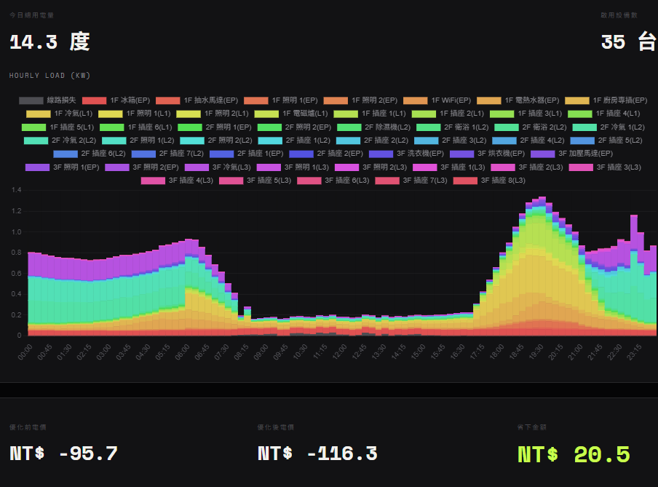
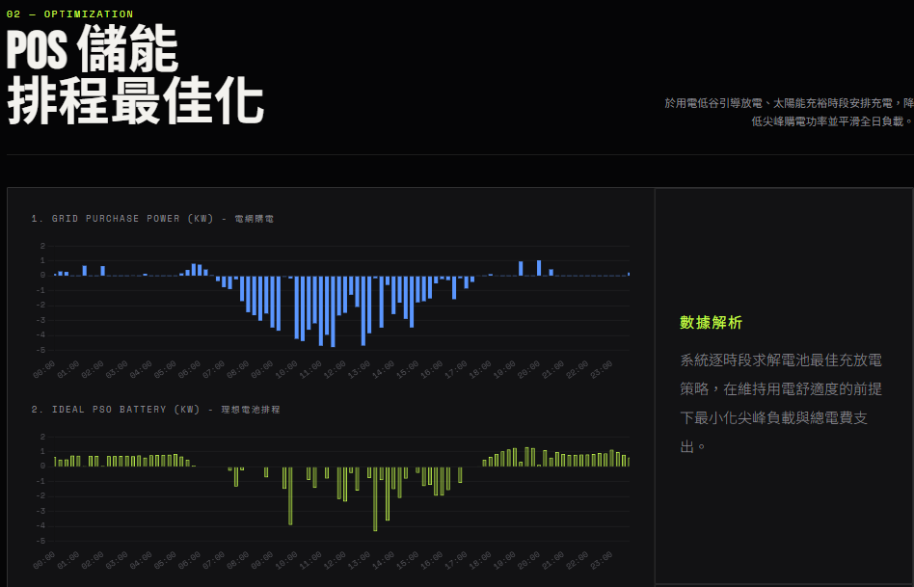
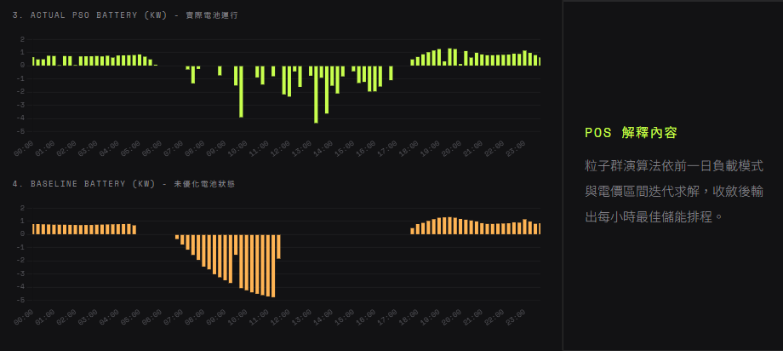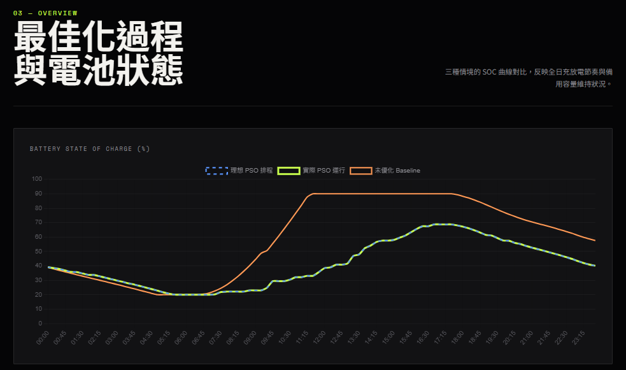
pso起始與結束電量
Time | soc
00:00 | 39.13
23:45 | 40.06

Baseline的起始與結束電量
Time | soc
00:00 | 38.95
23:45 | 57.55

S5測試2段式 無累計電價 有停電18:00~21:00 無設備啟用
📥 收到的 config： {'pricing': 'two_stage', 'season': 'summer', 'day_type': 'weekday', 'weather': 'sunny', 'monthly_cumulative_kwh': 0, 'outage': {'start_time': '18:00', 'end_time': '21:00'}, 'device_schedules': []}
🔁 [重試檢查] 第 0 次嘗試，目前 bess_override=None
🔎 [天氣檢查] PSO 這次使用的 PV 檔案：C:\projects\hems-simulation-web\data\01_raw\pv_curve_15min.csv
🔎 [PSO輸入比對] 13:00~15:00 PV: [4.78867, 4.6735299999999995, 4.56147, 4.415, 4.25413, 4.07467, 3.8710700000000005, 3.6598]
🔎 [PSO輸入比對] 13:00~15:00 critical_load_kw: [0.10398015000000001, 0.104320565, 0.105352634, 0.10483838199999998, 0.105803373, 0.10691419400000002, 0.10865781599999999, 0.11004641800000001]
🎯 [PSO自評] PSO演算法自己算出來的理論總成本(電費+懲罰項): -167.2954456978664
🔎 [天氣檢查] 離線驗證這次使用的 PV 檔案：pv_curve_15min.csv
🔍 [除錯] 目前實際使用的電池指令是: New Storage.Battery_Sys phases=1 bus1=Inv_AC.1.2 kV=0.22 kVA=6.0 kWrated=5.0 kWhrated=20.0 pf=1.0 %stored=40 %reserve=0 %IdlingKw=0 %EffCharge=95 %EffDischarge=95 DispMode=External
基準電路建置完成！開始進行 15 分鐘步進模擬 (模式: PSO)...
F12 Response
- {status: "success", message: "切換成功", pso_total_cost: 19.89, baseline_total_cost: 2.64,…}
baseline_adjusted_cost: -101.18
baseline_battery_asset_value: 0
baseline_export_kwh: 18.447
baseline_export_revenue: 103.82
baseline_had_overload: false
baseline_total_cost: 2.64
message: "切換成功"
pso_adjusted_cost: -166.59
pso_battery_asset_value: 0
pso_export_kwh: 33.135
pso_export_revenue: 186.48
pso_total_cost: 19.89
savings: 65.41
status: "success"
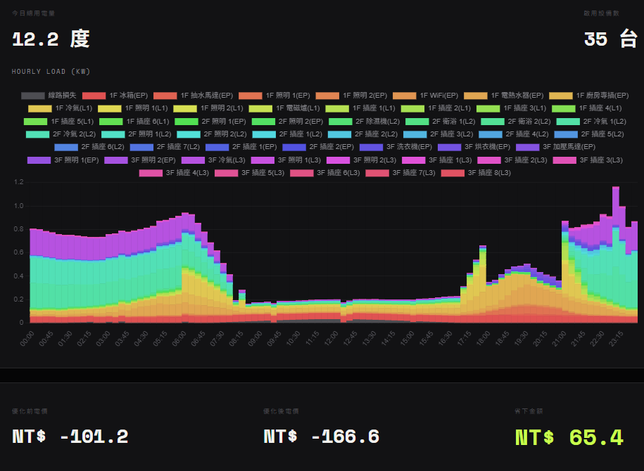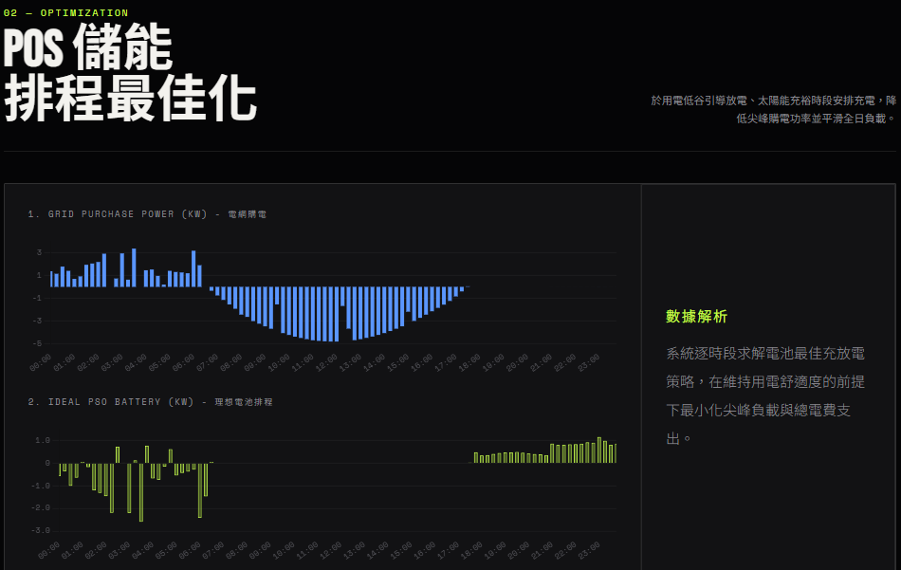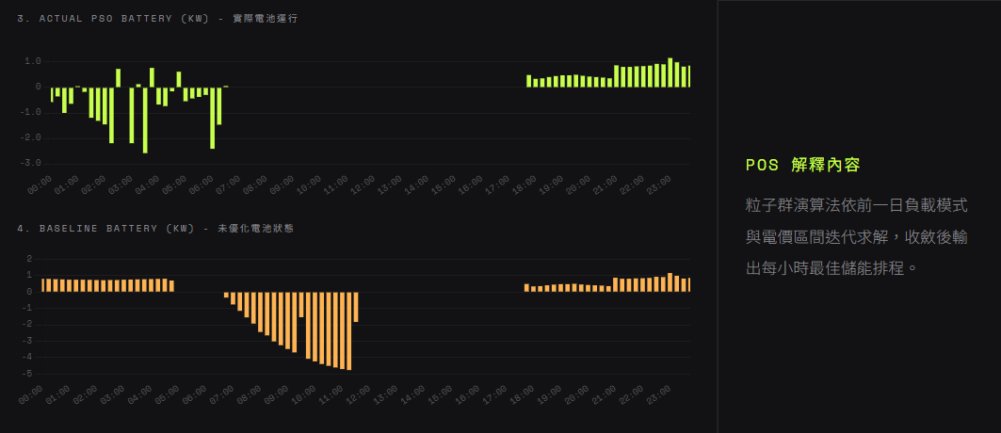
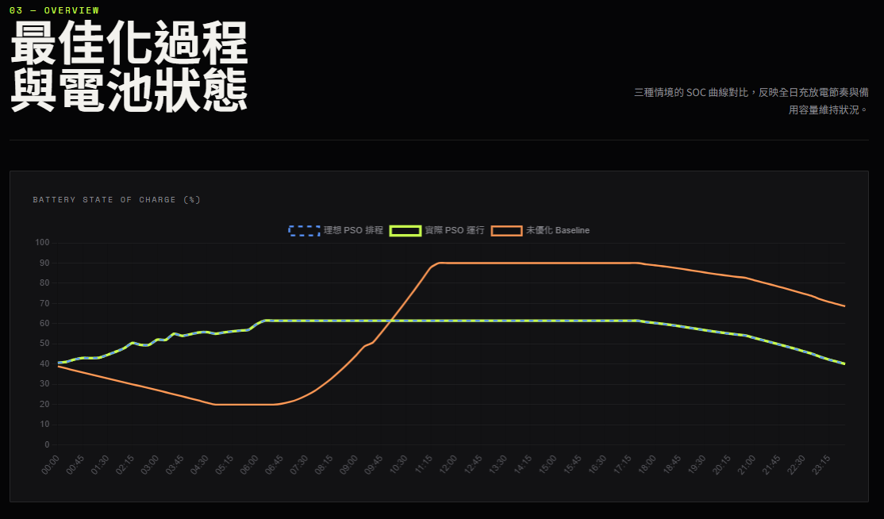
Pso的電量紀錄
Time | soc | battery_power_kw | current_a
00:00 | 40.68 | -0.57 | 2.62
00:15 | 41.1 | -0.35 | 1.61
00:30 | 42.29 | -1 | 4.56
00:45 | 43.05 | -0.64 | 2.91
01:00 | 42.97 | 0.05 | 0.25
01:15 | 43.18 | -0.17 | 0.79
01:30 | 44.6 | -1.19 | 5.45
01:45 | 46.15 | -1.31 | 5.98
02:00 | 47.88 | -1.45 | 6.64
02:15 | 50.47 | -2.19 | 10
02:30 | 49.51 | 0.73 | 3.33
02:45 | 49.51 | 0 | 0
03:00 | 52.11 | -2.19 | 10.01
03:15 | 51.94 | 0.13 | 0.59
03:30 | 55.01 | -2.58 | 11.81
03:45 | 53.99 | 0.77 | 3.53
04:00 | 54.79 | -0.67 | 3.07
04:15 | 55.66 | -0.73 | 3.32
04:30 | 55.84 | -0.15 | 0.7
04:45 | 55.02 | 0.62 | 2.85
05:00 | 55.66 | -0.54 | 2.48
05:15 | 56.17 | -0.43 | 1.96
05:30 | 56.61 | -0.37 | 1.7
05:45 | 56.95 | -0.29 | 1.3
06:00 | 59.81 | -2.41 | 11.01
06:15 | 61.55 | -1.46 | 6.68
06:30 | 61.48 | 0.06 | 0.26
06:45 | 61.48 | 0 | 0
07:00 | 61.48 | 0 | 0
07:15 | 61.48 | 0 | 0
07:30 | 61.48 | 0 | 0
07:45 | 61.48 | 0 | 0
08:00 | 61.48 | 0 | 0
08:15 | 61.48 | 0 | 0
08:30 | 61.48 | 0 | 0
08:45 | 61.48 | 0 | 0
09:00 | 61.48 | 0 | 0
09:15 | 61.48 | 0 | 0
09:30 | 61.48 | 0 | 0
09:45 | 61.48 | 0 | 0
10:00 | 61.48 | 0 | 0
10:15 | 61.48 | 0 | 0
10:30 | 61.48 | 0 | 0
10:45 | 61.48 | 0 | 0
11:00 | 61.48 | 0 | 0
11:15 | 61.48 | 0 | 0
11:30 | 61.48 | 0 | 0
11:45 | 61.48 | 0 | 0
12:00 | 61.48 | 0 | 0
12:15 | 61.48 | 0 | 0
12:30 | 61.48 | 0 | 0
12:45 | 61.48 | 0 | 0
13:00 | 61.48 | 0 | 0
13:15 | 61.48 | 0 | 0
13:30 | 61.48 | 0 | 0
13:45 | 61.48 | 0 | 0
14:00 | 61.48 | 0 | 0
14:15 | 61.48 | 0 | 0
14:30 | 61.48 | 0 | 0
14:45 | 61.48 | 0 | 0
15:00 | 61.48 | 0 | 0
15:15 | 61.48 | 0 | 0
15:30 | 61.48 | 0 | 0
15:45 | 61.48 | 0 | 0
16:00 | 61.48 | 0 | 0
16:15 | 61.48 | 0 | 0
16:30 | 61.48 | 0 | 0
16:45 | 61.48 | 0 | 0
17:00 | 61.48 | 0 | 0
17:15 | 61.48 | 0 | 0
17:30 | 61.48 | 0 | 0
17:45 | 60.84 | 0.49 | 2.21
18:00 | 60.38 | 0.34 | 1.56
18:15 | 59.91 | 0.36 | 1.65
18:30 | 59.36 | 0.41 | 1.88
18:45 | 58.77 | 0.45 | 2.06
19:00 | 58.13 | 0.48 | 2.18
19:15 | 57.5 | 0.48 | 2.2
19:30 | 56.84 | 0.5 | 2.27
19:45 | 56.23 | 0.46 | 2.11
20:00 | 55.66 | 0.43 | 1.96
20:15 | 55.12 | 0.41 | 1.86
20:30 | 54.61 | 0.39 | 1.78
20:45 | 54.14 | 0.36 | 1.63
21:00 | 53 | 0.87 | 3.95
21:15 | 51.94 | 0.81 | 3.67
21:30 | 50.86 | 0.81 | 3.71
21:45 | 49.77 | 0.83 | 3.8
22:00 | 48.66 | 0.84 | 3.83
22:15 | 47.53 | 0.86 | 3.92
22:30 | 46.31 | 0.93 | 4.22
22:45 | 45.12 | 0.91 | 4.13
23:00 | 43.59 | 1.16 | 5.28
23:15 | 42.29 | 0.99 | 4.51
23:30 | 41.21 | 0.82 | 3.72
23:45 | 40.07 | 0.86 | 3.94

Baseline的電池紀錄
Time | soc | battery_power_kw | current_a
00:00 | 38.95 | 0.8 | 3.65
00:15 | 37.9 | 0.8 | 3.63
00:30 | 36.87 | 0.78 | 3.55
00:45 | 35.86 | 0.77 | 3.5
01:00 | 34.87 | 0.75 | 3.44
01:15 | 33.88 | 0.75 | 3.41
01:30 | 32.9 | 0.75 | 3.4
01:45 | 31.93 | 0.74 | 3.36
02:00 | 30.97 | 0.73 | 3.33
02:15 | 30.02 | 0.72 | 3.29
02:30 | 29.06 | 0.73 | 3.33
02:45 | 28.09 | 0.73 | 3.33
03:00 | 27.11 | 0.75 | 3.41
03:15 | 26.11 | 0.76 | 3.47
03:30 | 25.09 | 0.77 | 3.53
03:45 | 24.07 | 0.78 | 3.53
04:00 | 23.04 | 0.79 | 3.58
04:15 | 21.99 | 0.8 | 3.63
04:30 | 20.92 | 0.81 | 3.69
04:45 | 20 | 0.7 | 3.19
05:00 | 20 | 0 | 0
05:15 | 20 | 0 | 0
05:30 | 20 | 0 | 0
05:45 | 20 | 0 | 0
06:00 | 20 | 0 | 0
06:15 | 20 | 0 | 0
06:30 | 20 | 0 | 0
06:45 | 20.41 | -0.34 | 1.56
07:00 | 21.3 | -0.76 | 3.44
07:15 | 22.67 | -1.15 | 5.24
07:30 | 24.51 | -1.55 | 7.07
07:45 | 26.8 | -1.93 | 8.79
08:00 | 29.7 | -2.44 | 11.14
08:15 | 32.85 | -2.65 | 12.06
08:30 | 36.43 | -3.02 | 13.75
08:45 | 40.28 | -3.25 | 14.79
09:00 | 44.42 | -3.48 | 15.86
09:15 | 48.81 | -3.69 | 16.84
09:30 | 50.64 | -1.54 | 7.03
09:45 | 55.48 | -4.08 | 18.59
10:00 | 60.52 | -4.24 | 19.34
10:15 | 65.74 | -4.4 | 20.04
10:30 | 71.1 | -4.51 | 20.55
10:45 | 76.57 | -4.61 | 21.02
11:00 | 82.17 | -4.71 | 21.48
11:15 | 87.83 | -4.77 | 21.73
11:30 | 90 | -1.83 | 8.29
11:45 | 90 | 0 | 0
12:00 | 90 | 0 | 0
12:15 | 90 | 0 | 0
12:30 | 90 | 0 | 0
12:45 | 90 | 0 | 0
13:00 | 90 | 0 | 0
13:15 | 90 | 0 | 0
13:30 | 90 | 0 | 0
13:45 | 90 | 0 | 0
14:00 | 90 | 0 | 0
14:15 | 90 | 0 | 0
14:30 | 90 | 0 | 0
14:45 | 90 | 0 | 0
15:00 | 90 | 0 | 0
15:15 | 90 | 0 | 0
15:30 | 90 | 0 | 0
15:45 | 90 | 0 | 0
16:00 | 90 | 0 | 0
16:15 | 90 | 0 | 0
16:30 | 90 | 0 | 0
16:45 | 90 | 0 | 0
17:00 | 90 | 0 | 0
17:15 | 90 | 0 | 0
17:30 | 90 | 0 | 0
17:45 | 89.36 | 0.49 | 2.21
18:00 | 88.91 | 0.34 | 1.56
18:15 | 88.43 | 0.36 | 1.65
18:30 | 87.89 | 0.41 | 1.88
18:45 | 87.29 | 0.45 | 2.06
19:00 | 86.66 | 0.48 | 2.18
19:15 | 86.02 | 0.48 | 2.2
19:30 | 85.37 | 0.5 | 2.27
19:45 | 84.75 | 0.46 | 2.11
20:00 | 84.19 | 0.43 | 1.96
20:15 | 83.65 | 0.41 | 1.86
20:30 | 83.13 | 0.39 | 1.78
20:45 | 82.66 | 0.36 | 1.63
21:00 | 81.52 | 0.87 | 3.95
21:15 | 80.46 | 0.81 | 3.67
21:30 | 79.39 | 0.81 | 3.71
21:45 | 78.29 | 0.83 | 3.8
22:00 | 77.18 | 0.84 | 3.83
22:15 | 76.05 | 0.86 | 3.92
22:30 | 74.83 | 0.93 | 4.22
22:45 | 73.64 | 0.91 | 4.13
23:00 | 72.12 | 1.16 | 5.28
23:15 | 70.81 | 0.99 | 4.51
23:30 | 69.74 | 0.82 | 3.72
23:45 | 68.6 | 0.86 | 3.94

S6測試2段式 無累計電價 有停電21:00~23:00 無設備啟用
📥 收到的 config： {'pricing': 'two_stage', 'season': 'summer', 'day_type': 'weekday', 'weather': 'sunny', 'monthly_cumulative_kwh': 0, 'outage': {'start_time': '21:00', 'end_time': '23:00'}, 'device_schedules': []}
🔁 [重試檢查] 第 0 次嘗試，目前 bess_override=None
🔎 [天氣檢查] PSO 這次使用的 PV 檔案：C:\projects\hems-simulation-web\data\01_raw\pv_curve_15min.csv
🔎 [PSO輸入比對] 13:00~15:00 PV: [4.78867, 4.6735299999999995, 4.56147, 4.415, 4.25413, 4.07467, 3.8710700000000005, 3.6598]
🔎 [PSO輸入比對] 13:00~15:00 critical_load_kw: [0.10398015000000001, 0.104320565, 0.105352634, 0.10483838199999998, 0.105803373, 0.10691419400000002, 0.10865781599999999, 0.11004641800000001]
🎯 [PSO自評] PSO演算法自己算出來的理論總成本(電費+懲罰項): -165.18417184463652
🔎 [天氣檢查] 離線驗證這次使用的 PV 檔案：pv_curve_15min.csv
🔍 [除錯] 目前實際使用的電池指令是: New Storage.Battery_Sys phases=1 bus1=Inv_AC.1.2 kV=0.22 kVA=6.0 kWrated=5.0 kWhrated=20.0 pf=1.0 %stored=40 %reserve=0 %IdlingKw=0 %EffCharge=95 %EffDischarge=95 DispMode=External
基準電路建置完成！開始進行 15 分鐘步進模擬 (模式: PSO)...
F12 Response
- {status: "success", message: "切換成功", pso_total_cost: 21.94, baseline_total_cost: 2.64,…}
baseline_adjusted_cost: -101.18
baseline_battery_asset_value: 0
baseline_export_kwh: 18.447
baseline_export_revenue: 103.82
baseline_had_overload: false
baseline_total_cost: 2.64
message: "切換成功"
pso_adjusted_cost: -164.5
pso_battery_asset_value: -0.04
pso_export_kwh: 33.135
pso_export_revenue: 186.48
pso_total_cost: 21.94
savings: 63.32
status: "success"
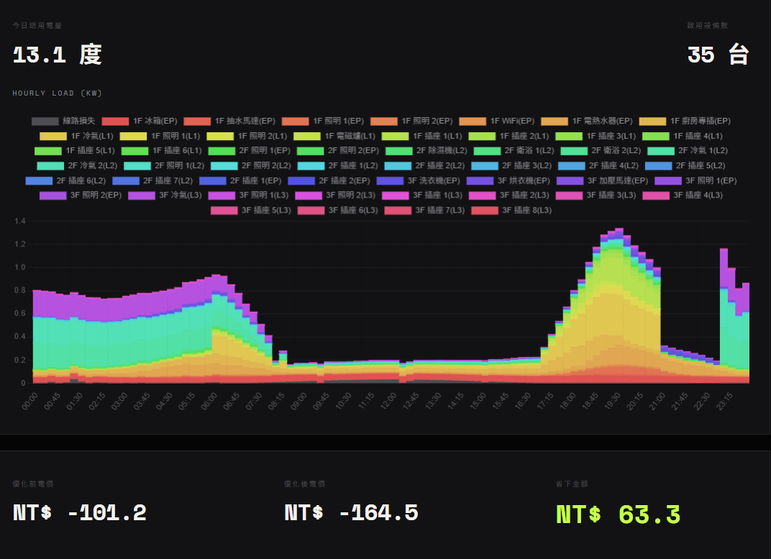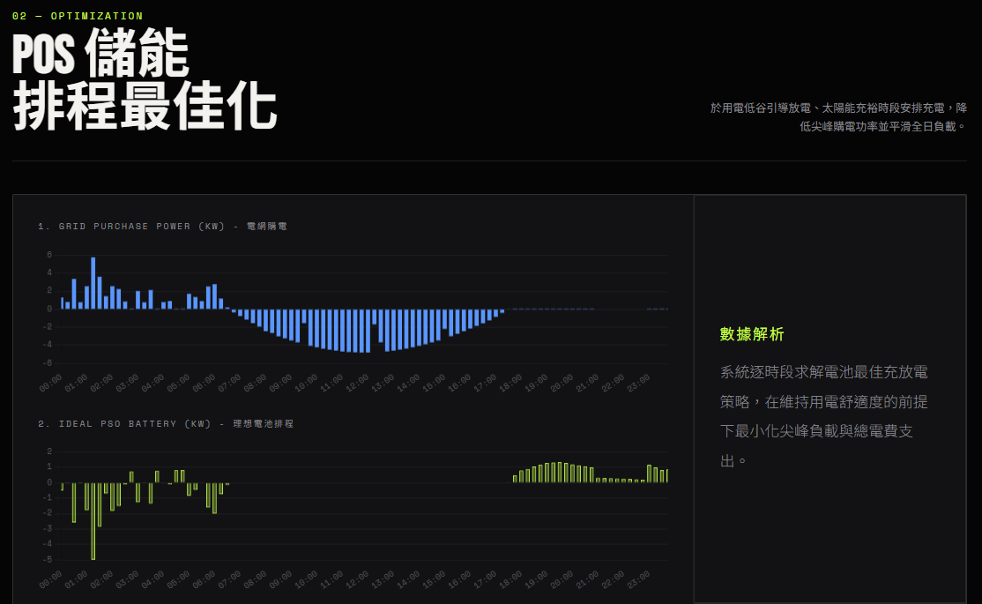
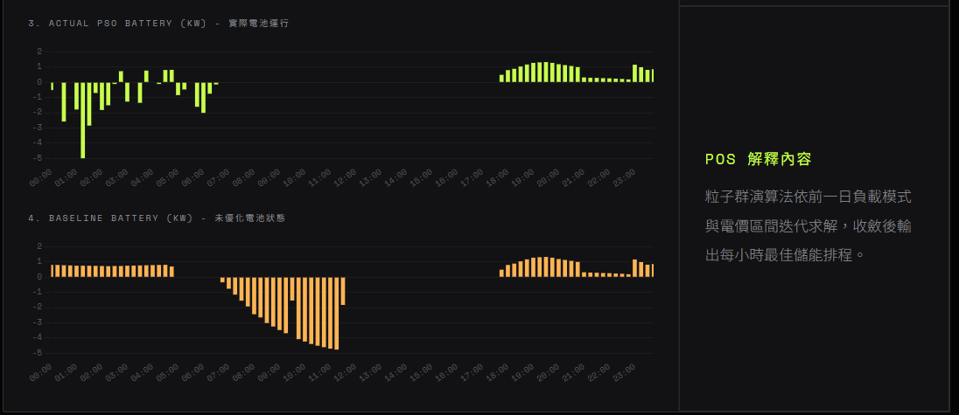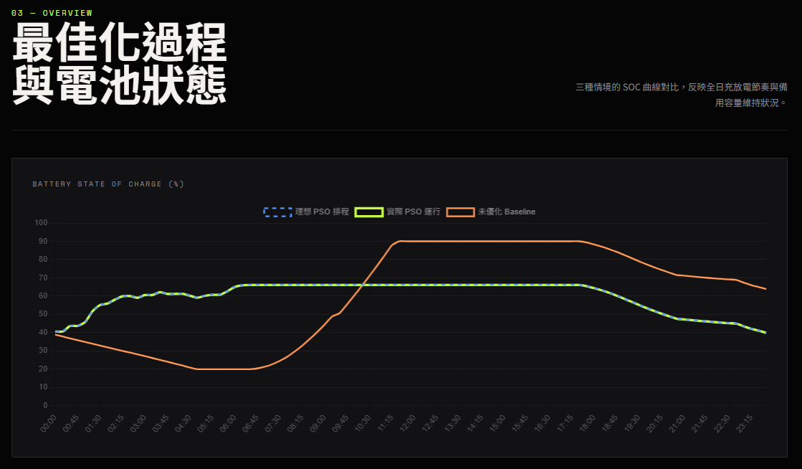

Pso的電池紀錄
Time | soc | battery_power_kw | current_a
00:00 | 40.6 | -0.51 | 2.3
00:15 | 40.6 | 0 | 0
00:30 | 43.67 | -2.58 | 11.81
00:45 | 43.67 | 0 | 0
01:00 | 45.79 | -1.79 | 8.19
01:15 | 51.73 | -5 | 22.93
01:30 | 55.11 | -2.85 | 13.03
01:45 | 55.95 | -0.7 | 3.22
02:00 | 58.11 | -1.82 | 8.32
02:15 | 59.91 | -1.51 | 6.92
02:30 | 60.05 | -0.11 | 0.52
02:45 | 59.08 | 0.73 | 3.33
03:00 | 60.59 | -1.27 | 5.81
03:15 | 60.59 | 0 | 0
03:30 | 62.2 | -1.35 | 6.17
03:45 | 61.18 | 0.77 | 3.53
04:00 | 61.18 | 0 | 0
04:15 | 61.3 | -0.11 | 0.49
04:30 | 60.24 | 0.81 | 3.69
04:45 | 59.15 | 0.82 | 3.75
05:00 | 60.16 | -0.84 | 3.85
05:15 | 60.72 | -0.47 | 2.15
05:30 | 60.72 | 0 | 0
05:45 | 62.63 | -1.61 | 7.37
06:00 | 65.02 | -2.01 | 9.19
06:15 | 65.91 | -0.75 | 3.41
06:30 | 66.07 | -0.14 | 0.63
06:45 | 66.07 | 0 | 0
07:00 | 66.07 | 0 | 0
07:15 | 66.07 | 0 | 0
07:30 | 66.07 | 0 | 0
07:45 | 66.07 | 0 | 0
08:00 | 66.07 | 0 | 0
08:15 | 66.07 | 0 | 0
08:30 | 66.07 | 0 | 0
08:45 | 66.07 | 0 | 0
09:00 | 66.07 | 0 | 0
09:15 | 66.07 | 0 | 0
09:30 | 66.07 | 0 | 0
09:45 | 66.07 | 0 | 0
10:00 | 66.07 | 0 | 0
10:15 | 66.07 | 0 | 0
10:30 | 66.07 | 0 | 0
10:45 | 66.07 | 0 | 0
11:00 | 66.07 | 0 | 0
11:15 | 66.07 | 0 | 0
11:30 | 66.07 | 0 | 0
11:45 | 66.07 | 0 | 0
12:00 | 66.07 | 0 | 0
12:15 | 66.07 | 0 | 0
12:30 | 66.07 | 0 | 0
12:45 | 66.07 | 0 | 0
13:00 | 66.07 | 0 | 0
13:15 | 66.07 | 0 | 0
13:30 | 66.07 | 0 | 0
13:45 | 66.07 | 0 | 0
14:00 | 66.07 | 0 | 0
14:15 | 66.07 | 0 | 0
14:30 | 66.07 | 0 | 0
14:45 | 66.07 | 0 | 0
15:00 | 66.07 | 0 | 0
15:15 | 66.07 | 0 | 0
15:30 | 66.07 | 0 | 0
15:45 | 66.07 | 0 | 0
16:00 | 66.07 | 0 | 0
16:15 | 66.07 | 0 | 0
16:30 | 66.07 | 0 | 0
16:45 | 66.07 | 0 | 0
17:00 | 66.07 | 0 | 0
17:15 | 66.07 | 0 | 0
17:30 | 66.07 | 0 | 0
17:45 | 65.43 | 0.49 | 2.21
18:00 | 64.38 | 0.8 | 3.64
18:15 | 63.21 | 0.89 | 4.06
18:30 | 61.83 | 1.04 | 4.76
18:45 | 60.29 | 1.17 | 5.34
19:00 | 58.61 | 1.28 | 5.83
19:15 | 56.88 | 1.31 | 5.97
19:30 | 55.12 | 1.33 | 6.08
19:45 | 53.45 | 1.28 | 5.81
20:00 | 51.88 | 1.19 | 5.41
20:15 | 50.4 | 1.13 | 5.14
20:30 | 48.99 | 1.07 | 4.86
20:45 | 47.68 | 1 | 4.54
21:00 | 47.26 | 0.32 | 1.46
21:15 | 46.86 | 0.3 | 1.37
21:30 | 46.49 | 0.29 | 1.3
21:45 | 46.13 | 0.27 | 1.23
22:00 | 45.79 | 0.26 | 1.17
22:15 | 45.48 | 0.24 | 1.1
22:30 | 45.19 | 0.22 | 0.98
22:45 | 44.94 | 0.19 | 0.87
23:00 | 43.42 | 1.16 | 5.28
23:15 | 42.11 | 0.99 | 4.51
23:30 | 41.04 | 0.82 | 3.72
23:45 | 39.9 | 0.86 | 3.94

Baseline的電池紀錄
Time | soc | battery_power_kw | current_a
00:00 | 38.95 | 0.8 | 3.65
00:15 | 37.9 | 0.8 | 3.63
00:30 | 36.87 | 0.78 | 3.55
00:45 | 35.86 | 0.77 | 3.5
01:00 | 34.87 | 0.75 | 3.44
01:15 | 33.88 | 0.75 | 3.41
01:30 | 32.9 | 0.75 | 3.4
01:45 | 31.93 | 0.74 | 3.36
02:00 | 30.97 | 0.73 | 3.33
02:15 | 30.02 | 0.72 | 3.29
02:30 | 29.06 | 0.73 | 3.33
02:45 | 28.09 | 0.73 | 3.33
03:00 | 27.11 | 0.75 | 3.41
03:15 | 26.11 | 0.76 | 3.47
03:30 | 25.09 | 0.77 | 3.53
03:45 | 24.07 | 0.78 | 3.53
04:00 | 23.04 | 0.79 | 3.58
04:15 | 21.99 | 0.8 | 3.63
04:30 | 20.92 | 0.81 | 3.69
04:45 | 20 | 0.7 | 3.19
05:00 | 20 | 0 | 0
05:15 | 20 | 0 | 0
05:30 | 20 | 0 | 0
05:45 | 20 | 0 | 0
06:00 | 20 | 0 | 0
06:15 | 20 | 0 | 0
06:30 | 20 | 0 | 0
06:45 | 20.41 | -0.34 | 1.56
07:00 | 21.3 | -0.76 | 3.44
07:15 | 22.67 | -1.15 | 5.24
07:30 | 24.51 | -1.55 | 7.07
07:45 | 26.8 | -1.93 | 8.79
08:00 | 29.7 | -2.44 | 11.14
08:15 | 32.85 | -2.65 | 12.06
08:30 | 36.43 | -3.02 | 13.75
08:45 | 40.28 | -3.25 | 14.79
09:00 | 44.42 | -3.48 | 15.86
09:15 | 48.81 | -3.69 | 16.84
09:30 | 50.64 | -1.54 | 7.03
09:45 | 55.48 | -4.08 | 18.59
10:00 | 60.52 | -4.24 | 19.34
10:15 | 65.74 | -4.4 | 20.04
10:30 | 71.1 | -4.51 | 20.55
10:45 | 76.57 | -4.61 | 21.02
11:00 | 82.17 | -4.71 | 21.48
11:15 | 87.83 | -4.77 | 21.73
11:30 | 90 | -1.83 | 8.29
11:45 | 90 | 0 | 0
12:00 | 90 | 0 | 0
12:15 | 90 | 0 | 0
12:30 | 90 | 0 | 0
12:45 | 90 | 0 | 0
13:00 | 90 | 0 | 0
13:15 | 90 | 0 | 0
13:30 | 90 | 0 | 0
13:45 | 90 | 0 | 0
14:00 | 90 | 0 | 0
14:15 | 90 | 0 | 0
14:30 | 90 | 0 | 0
14:45 | 90 | 0 | 0
15:00 | 90 | 0 | 0
15:15 | 90 | 0 | 0
15:30 | 90 | 0 | 0
15:45 | 90 | 0 | 0
16:00 | 90 | 0 | 0
16:15 | 90 | 0 | 0
16:30 | 90 | 0 | 0
16:45 | 90 | 0 | 0
17:00 | 90 | 0 | 0
17:15 | 90 | 0 | 0
17:30 | 90 | 0 | 0
17:45 | 89.36 | 0.49 | 2.21
18:00 | 88.31 | 0.8 | 3.64
18:15 | 87.14 | 0.89 | 4.06
18:30 | 85.76 | 1.04 | 4.76
18:45 | 84.22 | 1.17 | 5.34
19:00 | 82.53 | 1.28 | 5.83
19:15 | 80.81 | 1.31 | 5.97
19:30 | 79.05 | 1.33 | 6.08
19:45 | 77.37 | 1.28 | 5.81
20:00 | 75.81 | 1.19 | 5.41
20:15 | 74.33 | 1.13 | 5.14
20:30 | 72.92 | 1.07 | 4.86
20:45 | 71.61 | 1 | 4.54
21:00 | 71.19 | 0.32 | 1.46
21:15 | 70.79 | 0.3 | 1.37
21:30 | 70.41 | 0.29 | 1.3
21:45 | 70.06 | 0.27 | 1.23
22:00 | 69.72 | 0.26 | 1.17
22:15 | 69.4 | 0.24 | 1.1
22:30 | 69.12 | 0.22 | 0.98
22:45 | 68.87 | 0.19 | 0.87
23:00 | 67.34 | 1.16 | 5.28
23:15 | 66.04 | 0.99 | 4.51
23:30 | 64.96 | 0.82 | 3.72
23:45 | 63.83 | 0.86 | 3.94

S7測試2段式 無累計電價 無停電 有設備啟用 冷氣14:00-16:00
📥 收到的 config： {'pricing': 'two_stage', 'season': 'summer', 'day_type': 'weekday', 'weather': 'sunny', 'monthly_cumulative_kwh': 0, 'outage': None, 'device_schedules': [{'column': 'l2_airc2_abn', 'start_time': '14:00', 'end_time': '16:00'}]}
🔁 [重試檢查] 第 0 次嘗試，目前 bess_override=None
🔎 [天氣檢查] PSO 這次使用的 PV 檔案：C:\projects\hems-simulation-web\data\01_raw\pv_curve_15min.csv
🔎 [PSO輸入比對] 13:00~15:00 PV: [4.78867, 4.6735299999999995, 4.56147, 4.415, 4.25413, 4.07467, 3.8710700000000005, 3.6598]
🔎 [PSO輸入比對] 13:00~15:00 critical_load_kw: [0.10398015000000001, 0.104320565, 0.105352634, 0.10483838199999998, 0.105803373, 0.10691419400000002, 0.10865781599999999, 0.11004641800000001]
🎯 [PSO自評] PSO演算法自己算出來的理論總成本(電費+懲罰項): -149.19849840594375
🔎 [天氣檢查] 離線驗證這次使用的 PV 檔案：pv_curve_15min.csv
🔍 [除錯] 目前實際使用的電池指令是: New Storage.Battery_Sys phases=1 bus1=Inv_AC.1.2 kV=0.22 kVA=6.0 kWrated=5.0 kWhrated=20.0 pf=1.0 %stored=40 %reserve=0 %IdlingKw=0 %EffCharge=95 %EffDischarge=95 DispMode=External
基準電路建置完成！開始進行 15 分鐘步進模擬 (模式: PSO)...

F12 Response
- {status: "success", message: "切換成功", pso_total_cost: 24.7, baseline_total_cost: 2.65,…}
baseline_adjusted_cost: -87.83
baseline_battery_asset_value: 0
baseline_export_kwh: 16.077
baseline_export_revenue: 90.48
baseline_had_overload: false
baseline_total_cost: 2.65
message: "切換成功"
pso_adjusted_cost: -148.45
pso_battery_asset_value: 0
pso_export_kwh: 30.766
pso_export_revenue: 173.15
pso_total_cost: 24.7
savings: 60.62
status: "success"
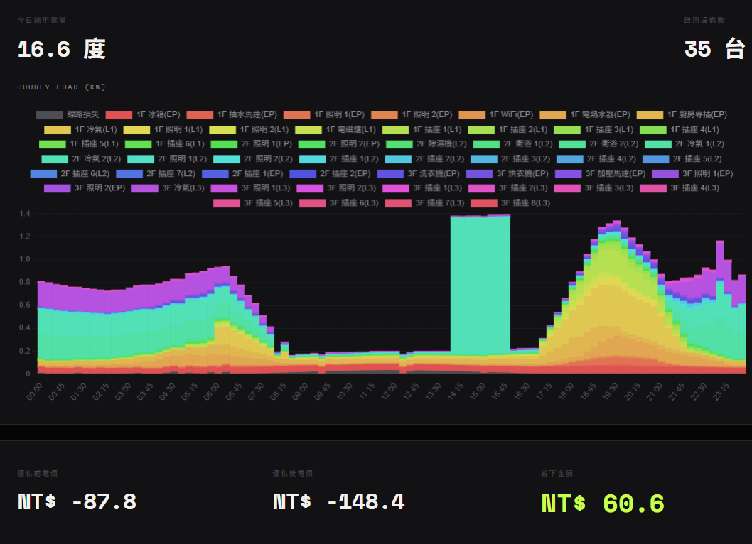
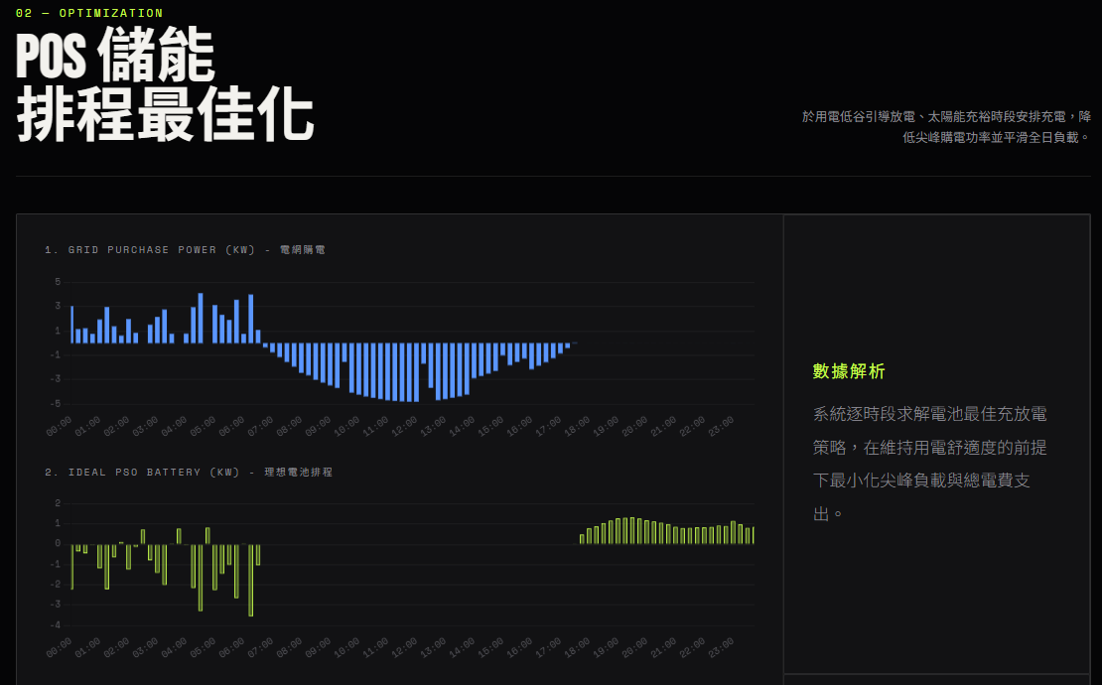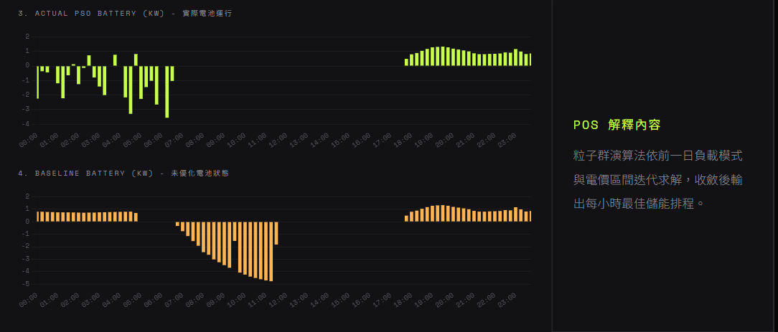
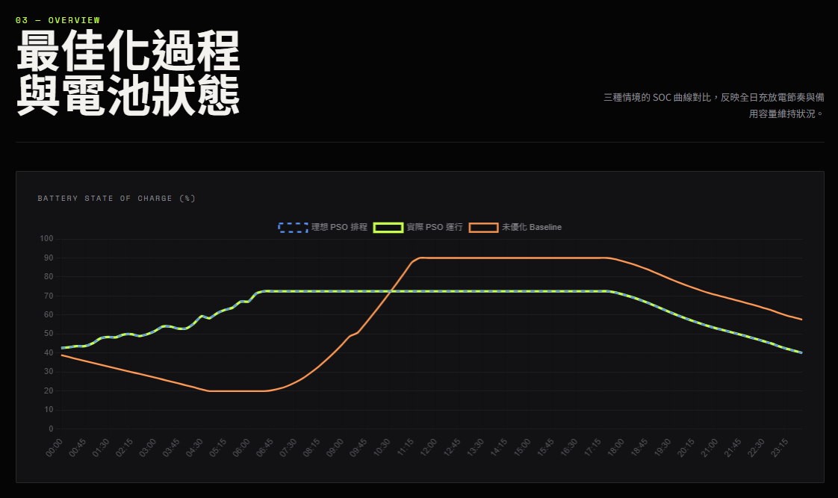
pso起始與結束電量
Time | soc | battery_power_kw | current_a
00:00 | 42.65 | -2.24 | 10.22
00:15 | 43.08 | -0.36 | 1.63
00:30 | 43.6 | -0.44 | 2.01
00:45 | 43.6 | 0 | 0
01:00 | 45.02 | -1.19 | 5.43
01:15 | 47.65 | -2.22 | 10.14
01:30 | 48.41 | -0.64 | 2.9
01:45 | 48.25 | 0.12 | 0.53
02:00 | 49.74 | -1.25 | 5.71
02:15 | 49.89 | -0.13 | 0.58
02:30 | 48.93 | 0.73 | 3.33
02:45 | 49.86 | -0.79 | 3.59
03:00 | 51.53 | -1.41 | 6.44
03:15 | 53.91 | -2 | 9.16
03:30 | 53.91 | 0 | 0
03:45 | 52.89 | 0.77 | 3.53
04:00 | 52.89 | 0 | 0
04:15 | 55.45 | -2.16 | 9.85
04:30 | 59.36 | -3.29 | 15.07
04:45 | 58.28 | 0.82 | 3.75
05:00 | 60.96 | -2.26 | 10.33
05:15 | 62.69 | -1.45 | 6.64
05:30 | 63.9 | -1.02 | 4.64
05:45 | 67.05 | -2.65 | 12.14
06:00 | 67.05 | 0 | 0
06:15 | 71.28 | -3.56 | 16.3
06:30 | 72.5 | -1.03 | 4.71
06:45 | 72.5 | 0 | 0
07:00 | 72.5 | 0 | 0
07:15 | 72.5 | 0 | 0
07:30 | 72.5 | 0 | 0
07:45 | 72.5 | 0 | 0
08:00 | 72.5 | 0 | 0
08:15 | 72.5 | 0 | 0
08:30 | 72.5 | 0 | 0
08:45 | 72.5 | 0 | 0
09:00 | 72.5 | 0 | 0
09:15 | 72.5 | 0 | 0
09:30 | 72.5 | 0 | 0
09:45 | 72.5 | 0 | 0
10:00 | 72.5 | 0 | 0
10:15 | 72.5 | 0 | 0
10:30 | 72.5 | 0 | 0
10:45 | 72.5 | 0 | 0
11:00 | 72.5 | 0 | 0
11:15 | 72.5 | 0 | 0
11:30 | 72.5 | 0 | 0
11:45 | 72.5 | 0 | 0
12:00 | 72.5 | 0 | 0
12:15 | 72.5 | 0 | 0
12:30 | 72.5 | 0 | 0
12:45 | 72.5 | 0 | 0
13:00 | 72.5 | 0 | 0
13:15 | 72.5 | 0 | 0
13:30 | 72.5 | 0 | 0
13:45 | 72.5 | 0 | 0
14:00 | 72.5 | 0 | 0
14:15 | 72.5 | 0 | 0
14:30 | 72.5 | 0 | 0
14:45 | 72.5 | 0 | 0
15:00 | 72.5 | 0 | 0
15:15 | 72.5 | 0 | 0
15:30 | 72.5 | 0 | 0
15:45 | 72.5 | 0 | 0
16:00 | 72.5 | 0 | 0
16:15 | 72.5 | 0 | 0
16:30 | 72.5 | 0 | 0
16:45 | 72.5 | 0 | 0
17:00 | 72.5 | 0 | 0
17:15 | 72.5 | 0 | 0
17:30 | 72.5 | 0 | 0
17:45 | 71.86 | 0.49 | 2.21
18:00 | 70.81 | 0.8 | 3.64
18:15 | 69.64 | 0.89 | 4.06
18:30 | 68.26 | 1.04 | 4.76
18:45 | 66.72 | 1.17 | 5.34
19:00 | 65.03 | 1.28 | 5.83
19:15 | 63.31 | 1.31 | 5.97
19:30 | 61.55 | 1.33 | 6.08
19:45 | 59.87 | 1.28 | 5.81
20:00 | 58.31 | 1.19 | 5.41
20:15 | 56.83 | 1.13 | 5.14
20:30 | 55.42 | 1.07 | 4.86
20:45 | 54.11 | 1 | 4.54
21:00 | 52.97 | 0.87 | 3.95
21:15 | 51.91 | 0.81 | 3.67
21:30 | 50.84 | 0.81 | 3.71
21:45 | 49.74 | 0.83 | 3.8
22:00 | 48.63 | 0.84 | 3.83
22:15 | 47.5 | 0.86 | 3.92
22:30 | 46.28 | 0.93 | 4.22
22:45 | 45.09 | 0.91 | 4.13
23:00 | 43.56 | 1.16 | 5.28
23:15 | 42.26 | 0.99 | 4.51
23:30 | 41.19 | 0.82 | 3.72
23:45 | 40.05 | 0.86 | 3.94

Baseline的電池記錄
Time | soc | battery_power_kw | current_a
00:00 | 38.95 | 0.8 | 3.65
00:15 | 37.9 | 0.8 | 3.63
00:30 | 36.87 | 0.78 | 3.55
00:45 | 35.86 | 0.77 | 3.5
01:00 | 34.87 | 0.75 | 3.44
01:15 | 33.88 | 0.75 | 3.41
01:30 | 32.9 | 0.75 | 3.4
01:45 | 31.93 | 0.74 | 3.36
02:00 | 30.97 | 0.73 | 3.33
02:15 | 30.02 | 0.72 | 3.29
02:30 | 29.06 | 0.73 | 3.33
02:45 | 28.09 | 0.73 | 3.33
03:00 | 27.11 | 0.75 | 3.41
03:15 | 26.11 | 0.76 | 3.47
03:30 | 25.09 | 0.77 | 3.53
03:45 | 24.07 | 0.78 | 3.53
04:00 | 23.04 | 0.79 | 3.58
04:15 | 21.99 | 0.8 | 3.63
04:30 | 20.92 | 0.81 | 3.69
04:45 | 20 | 0.7 | 3.19
05:00 | 20 | 0 | 0
05:15 | 20 | 0 | 0
05:30 | 20 | 0 | 0
05:45 | 20 | 0 | 0
06:00 | 20 | 0 | 0
06:15 | 20 | 0 | 0
06:30 | 20 | 0 | 0
06:45 | 20.41 | -0.34 | 1.56
07:00 | 21.3 | -0.76 | 3.44
07:15 | 22.67 | -1.15 | 5.24
07:30 | 24.51 | -1.55 | 7.07
07:45 | 26.8 | -1.93 | 8.79
08:00 | 29.7 | -2.44 | 11.14
08:15 | 32.85 | -2.65 | 12.06
08:30 | 36.43 | -3.02 | 13.75
08:45 | 40.28 | -3.25 | 14.79
09:00 | 44.42 | -3.48 | 15.86
09:15 | 48.81 | -3.69 | 16.84
09:30 | 50.64 | -1.54 | 7.03
09:45 | 55.48 | -4.08 | 18.59
10:00 | 60.52 | -4.24 | 19.34
10:15 | 65.74 | -4.4 | 20.04
10:30 | 71.1 | -4.51 | 20.55
10:45 | 76.57 | -4.61 | 21.02
11:00 | 82.17 | -4.71 | 21.48
11:15 | 87.83 | -4.77 | 21.73
11:30 | 90 | -1.83 | 8.29
11:45 | 90 | 0 | 0
12:00 | 90 | 0 | 0
12:15 | 90 | 0 | 0
12:30 | 90 | 0 | 0
12:45 | 90 | 0 | 0
13:00 | 90 | 0 | 0
13:15 | 90 | 0 | 0
13:30 | 90 | 0 | 0
13:45 | 90 | 0 | 0
14:00 | 90 | 0 | 0
14:15 | 90 | 0 | 0
14:30 | 90 | 0 | 0
14:45 | 90 | 0 | 0
15:00 | 90 | 0 | 0
15:15 | 90 | 0 | 0
15:30 | 90 | 0 | 0
15:45 | 90 | 0 | 0
16:00 | 90 | 0 | 0
16:15 | 90 | 0 | 0
16:30 | 90 | 0 | 0
16:45 | 90 | 0 | 0
17:00 | 90 | 0 | 0
17:15 | 90 | 0 | 0
17:30 | 90 | 0 | 0
17:45 | 89.36 | 0.49 | 2.21
18:00 | 88.31 | 0.8 | 3.64
18:15 | 87.14 | 0.89 | 4.06
18:30 | 85.76 | 1.04 | 4.76
18:45 | 84.22 | 1.17 | 5.34
19:00 | 82.53 | 1.28 | 5.83
19:15 | 80.81 | 1.31 | 5.97
19:30 | 79.05 | 1.33 | 6.08
19:45 | 77.37 | 1.28 | 5.81
20:00 | 75.81 | 1.19 | 5.41
20:15 | 74.33 | 1.13 | 5.14
20:30 | 72.92 | 1.07 | 4.86
20:45 | 71.61 | 1 | 4.54
21:00 | 70.47 | 0.87 | 3.95
21:15 | 69.41 | 0.81 | 3.67
21:30 | 68.34 | 0.81 | 3.71
21:45 | 67.24 | 0.83 | 3.8
22:00 | 66.13 | 0.84 | 3.83
22:15 | 65 | 0.86 | 3.92
22:30 | 63.78 | 0.93 | 4.22
22:45 | 62.59 | 0.91 | 4.13
23:00 | 61.06 | 1.16 | 5.28
23:15 | 59.76 | 0.99 | 4.51
23:30 | 58.68 | 0.82 | 3.72
23:45 | 57.55 | 0.86 | 3.94

